Practice Activity Number 23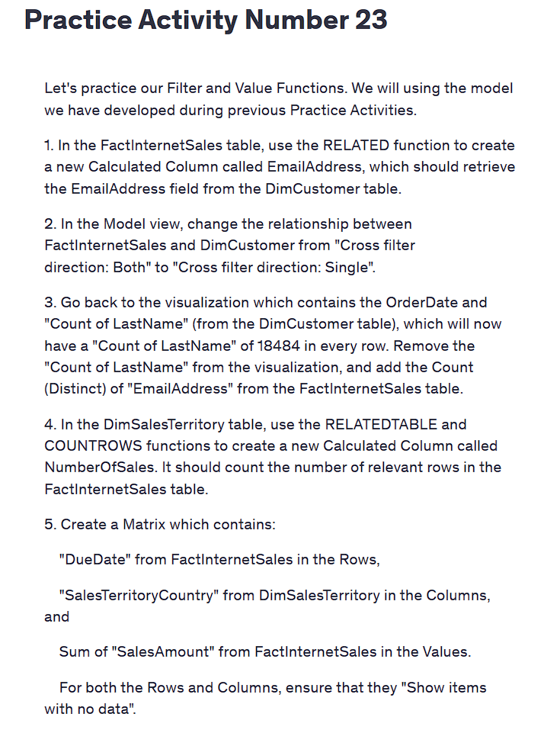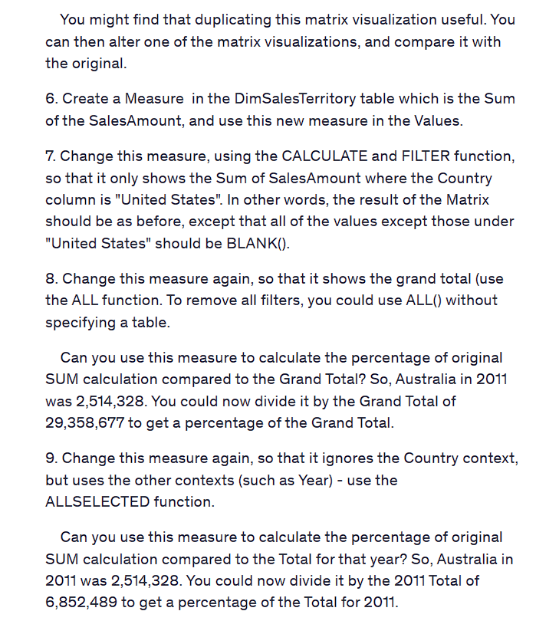

Practice Activity Number 23

Let's practice our Filter and Value Functions. We will using the model we have developed during previous Practice Activities.

1. In the FactInternetSales table, use the RELATED function to create a new Calculated Column called EmailAddress, which should retrieve the EmailAddress field from the DimCustomer table.

2. In the Model view, change the relationship between FactInternetSales and DimCustomer from "Cross filter direction: Both" to "Cross filter direction: Single".

3. Go back to the visualization which contains the OrderDate and "Count of LastName" (from the DimCustomer table), which will now have a "Count of LastName" of 18484 in every row. Remove the "Count of LastName" from the visualization, and add the Count (Distinct) of "EmailAddress" from the FactInternetSales table.

4. In the DimSalesTerritory table, use the RELATEDTABLE and COUNTROWS functions to create a new Calculated Column called NumberOfSales. It should count the number of relevant rows in the FactInternetSales table.

5. Create a Matrix which contains:

"DueDate" from FactInternetSales in the Rows,

"SalesTerritoryCountry" from DimSalesTerritory in the Columns, and

Sum of "SalesAmount" from FactInternetSales in the Values.

For both the Rows and Columns, ensure that they "Show items with no data".

You might find that duplicating this matrix visualization useful. You can then alter one of the matrix visualizations, and compare it with the original.

6. Create a Measure in the DimSalesTerritory table which is the Sum of the SalesAmount, and use this new measure in the Values.

7. Change this measure, using the CALCULATE and FILTER function, so that it only shows the Sum of SalesAmount where the Country column is "United States". In other words, the result of the Matrix should be as before, except that all of the values except those under "United States" should be BLANK().

8. Change this measure again, so that it shows the grand total (use the ALL function. To remove all filters, you could use ALL() without specifying a table.

Can you use this measure to calculate the percentage of original SUM calculation compared to the Grand Total? So, Australia in 2011 was 2,514,328. You could now divide it by the Grand Total of 29,358,677 to get a percentage of the Grand Total.

9. Change this measure again, so that it ignores the Country context, but uses the other contexts (such as Year) - use the ALLSELECTED function.

Can you use this measure to calculate the percentage of original SUM calculation compared to the Total for that year? So, Australia in 2011 was 2,514,328. You could now divide it by the 2011 Total of 6,852,489 to get a percentage of the Total for 2011.